Kenya

## GNI per capita and development level

The data set shows the GNI per capita and development level of the country each year.

## # A tibble: 19 x 5  
## country iso3c date GNIperCapita devCategory   
## <chr> <chr> <dbl> <dbl> <chr>   
## 1 Kenya KEN 1996 843. Low Income   
## 2 Kenya KEN 1998 834. Low Income   
## 3 Kenya KEN 2000 812. Low Income   
## 4 Kenya KEN 2002 803. Low Income   
## 5 Kenya KEN 2003 803. Low Income   
## 6 Kenya KEN 2004 823. Low Income   
## 7 Kenya KEN 2005 855. Low Income   
## 8 Kenya KEN 2006 883. Low Income   
## 9 Kenya KEN 2007 917. Low Income   
## 10 Kenya KEN 2008 897. Low Income   
## 11 Kenya KEN 2009 901. Low Income   
## 12 Kenya KEN 2010 948. Low Income   
## 13 Kenya KEN 2011 983. Low Income   
## 14 Kenya KEN 2012 996. Low Income   
## 15 Kenya KEN 2013 1021. Low Income   
## 16 Kenya KEN 2014 1046. Lower Middle Income  
## 17 Kenya KEN 2015 1079. Lower Middle Income  
## 18 Kenya KEN 2016 1113. Lower Middle Income  
## 19 Kenya KEN 2017 1134. Lower Middle Income

## GDP growth and economic growth classification

The data set shows the GDP growth and the ecomic growth classification of the country each year.

## # A tibble: 19 x 5  
## country iso3c date GDPannualGrowthRate GDPgrowthCategory4  
## <chr> <chr> <dbl> <dbl> <fct>   
## 1 Kenya KEN 1996 4.15 moderate growth   
## 2 Kenya KEN 1998 3.29 moderate growth   
## 3 Kenya KEN 2000 0.600 slow growth   
## 4 Kenya KEN 2002 0.547 slow growth   
## 5 Kenya KEN 2003 2.93 moderate growth   
## 6 Kenya KEN 2004 5.10 moderate growth   
## 7 Kenya KEN 2005 5.91 fast growth   
## 8 Kenya KEN 2006 6.47 fast growth   
## 9 Kenya KEN 2007 6.85 fast growth   
## 10 Kenya KEN 2008 0.232 slow growth   
## 11 Kenya KEN 2009 3.31 moderate growth   
## 12 Kenya KEN 2010 8.41 fast growth   
## 13 Kenya KEN 2011 6.11 fast growth   
## 14 Kenya KEN 2012 4.56 moderate growth   
## 15 Kenya KEN 2013 5.88 fast growth   
## 16 Kenya KEN 2014 5.36 moderate growth   
## 17 Kenya KEN 2015 5.72 fast growth   
## 18 Kenya KEN 2016 5.88 fast growth   
## 19 Kenya KEN 2017 4.81 moderate growth

## Development trend

The plot shows the development trend of the country.

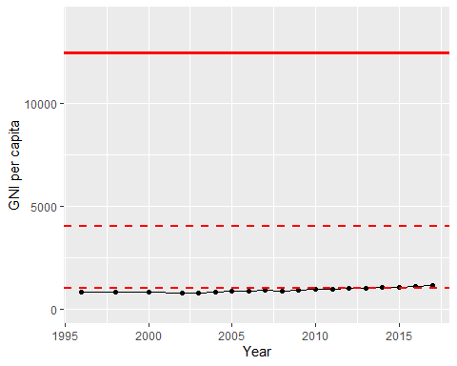

GNI Per Capita Trend